**SonarQube Assignment 29/06/2023**

Check the quality of Code in SonarQube

Step 1: Install the SonarQube in the server choose t2.medium for SonarQube

Git URL to clone into the server for Installation: [AnandReddy-1565/SonarQube-installation (github.com)](https://github.com/AnandReddy-1565/SonarQube-installation)

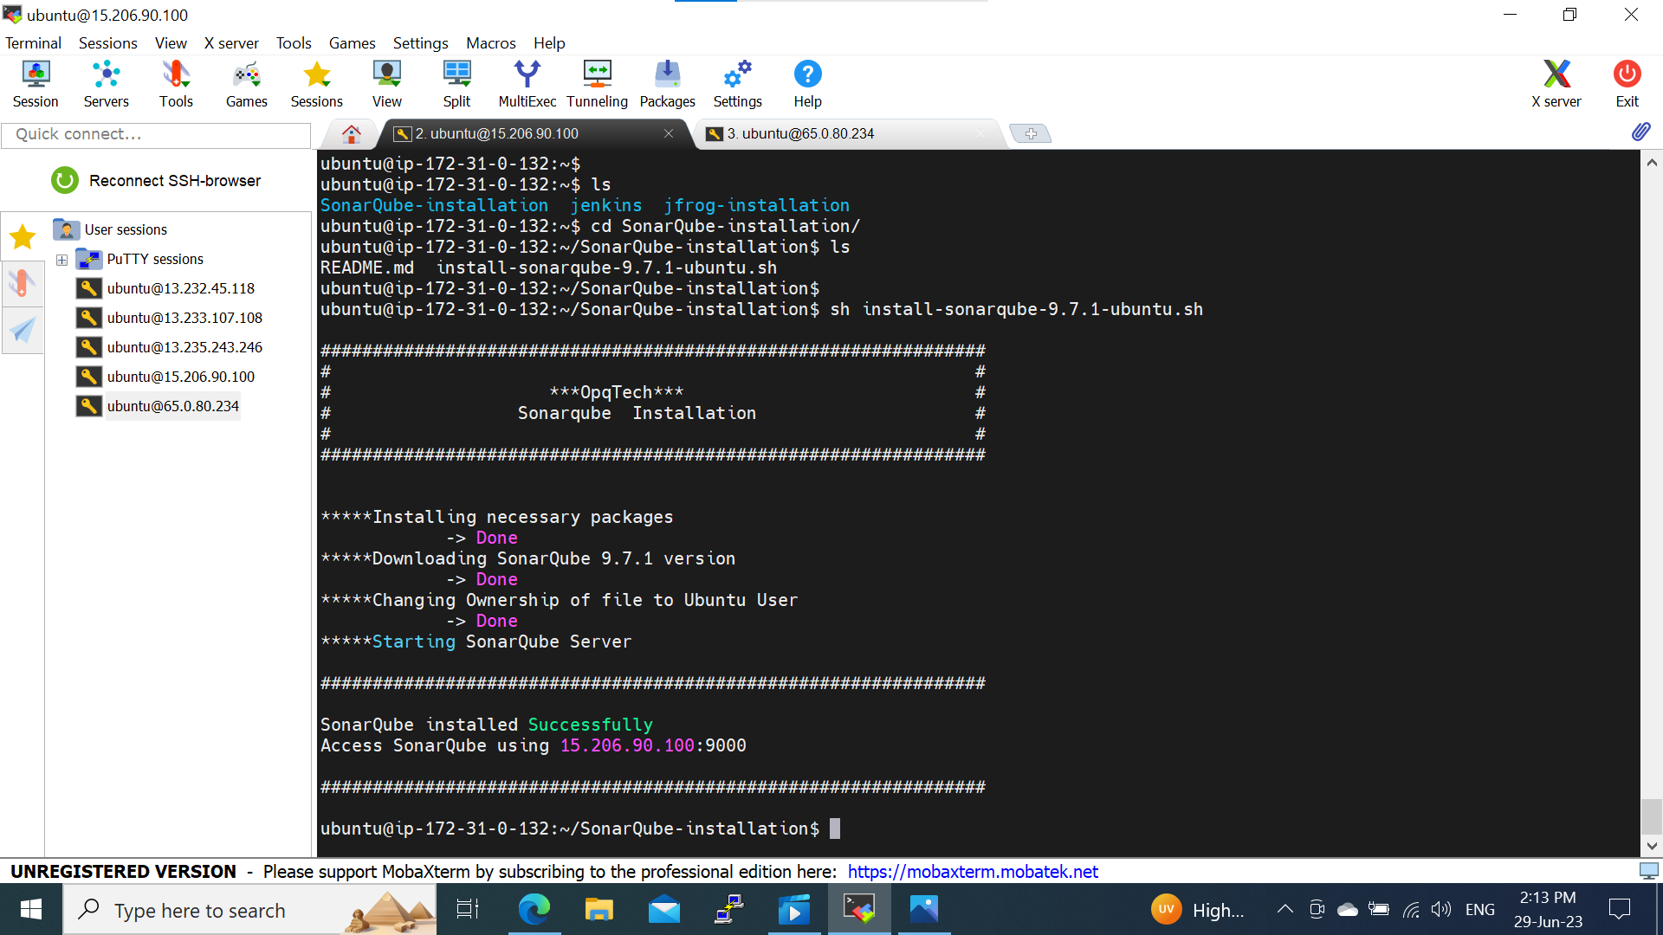

Step 2 : Login into the SonarQube webpage using Public IP address and port number-9000

Username: admin

Password : admin and select manually for new setup

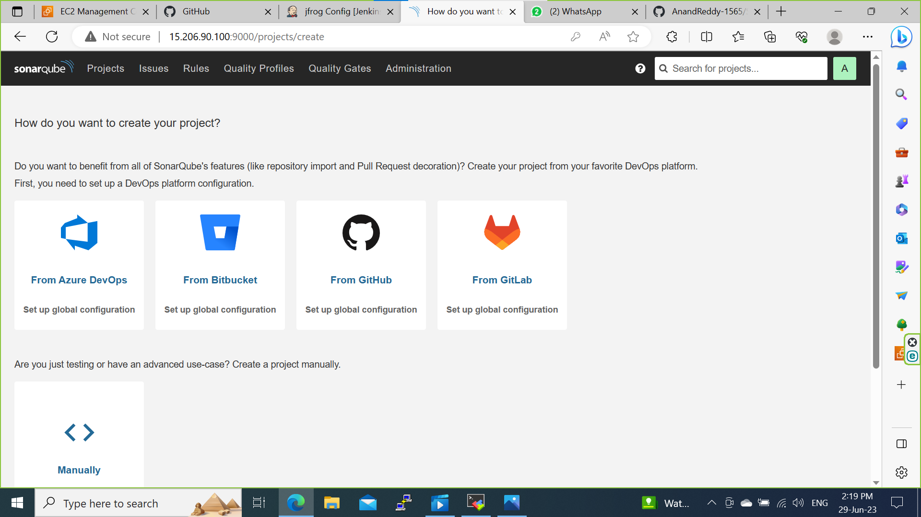

Step 3: Give Project display name and click on setup.

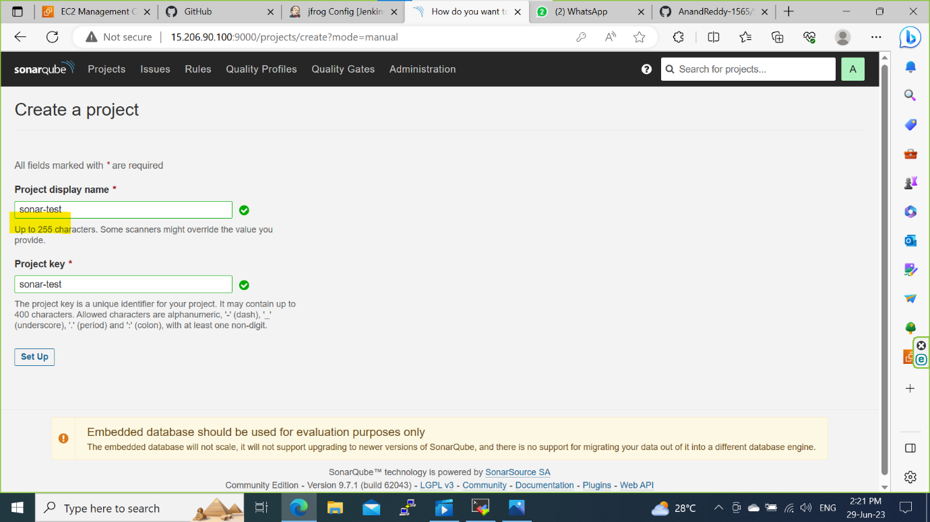

Step 4: Click on Locally.

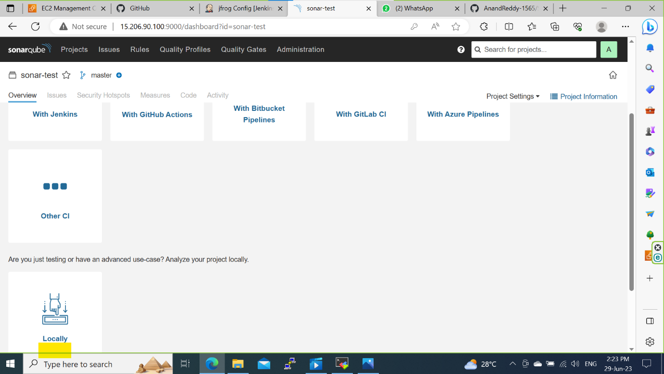

Step 5: Give token name and generate the token key

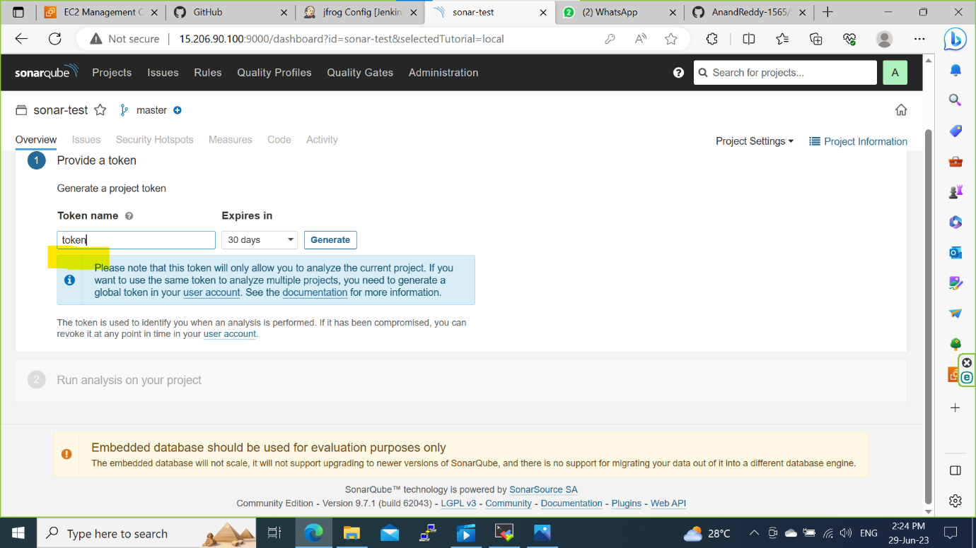

Step 6: Click on Continue

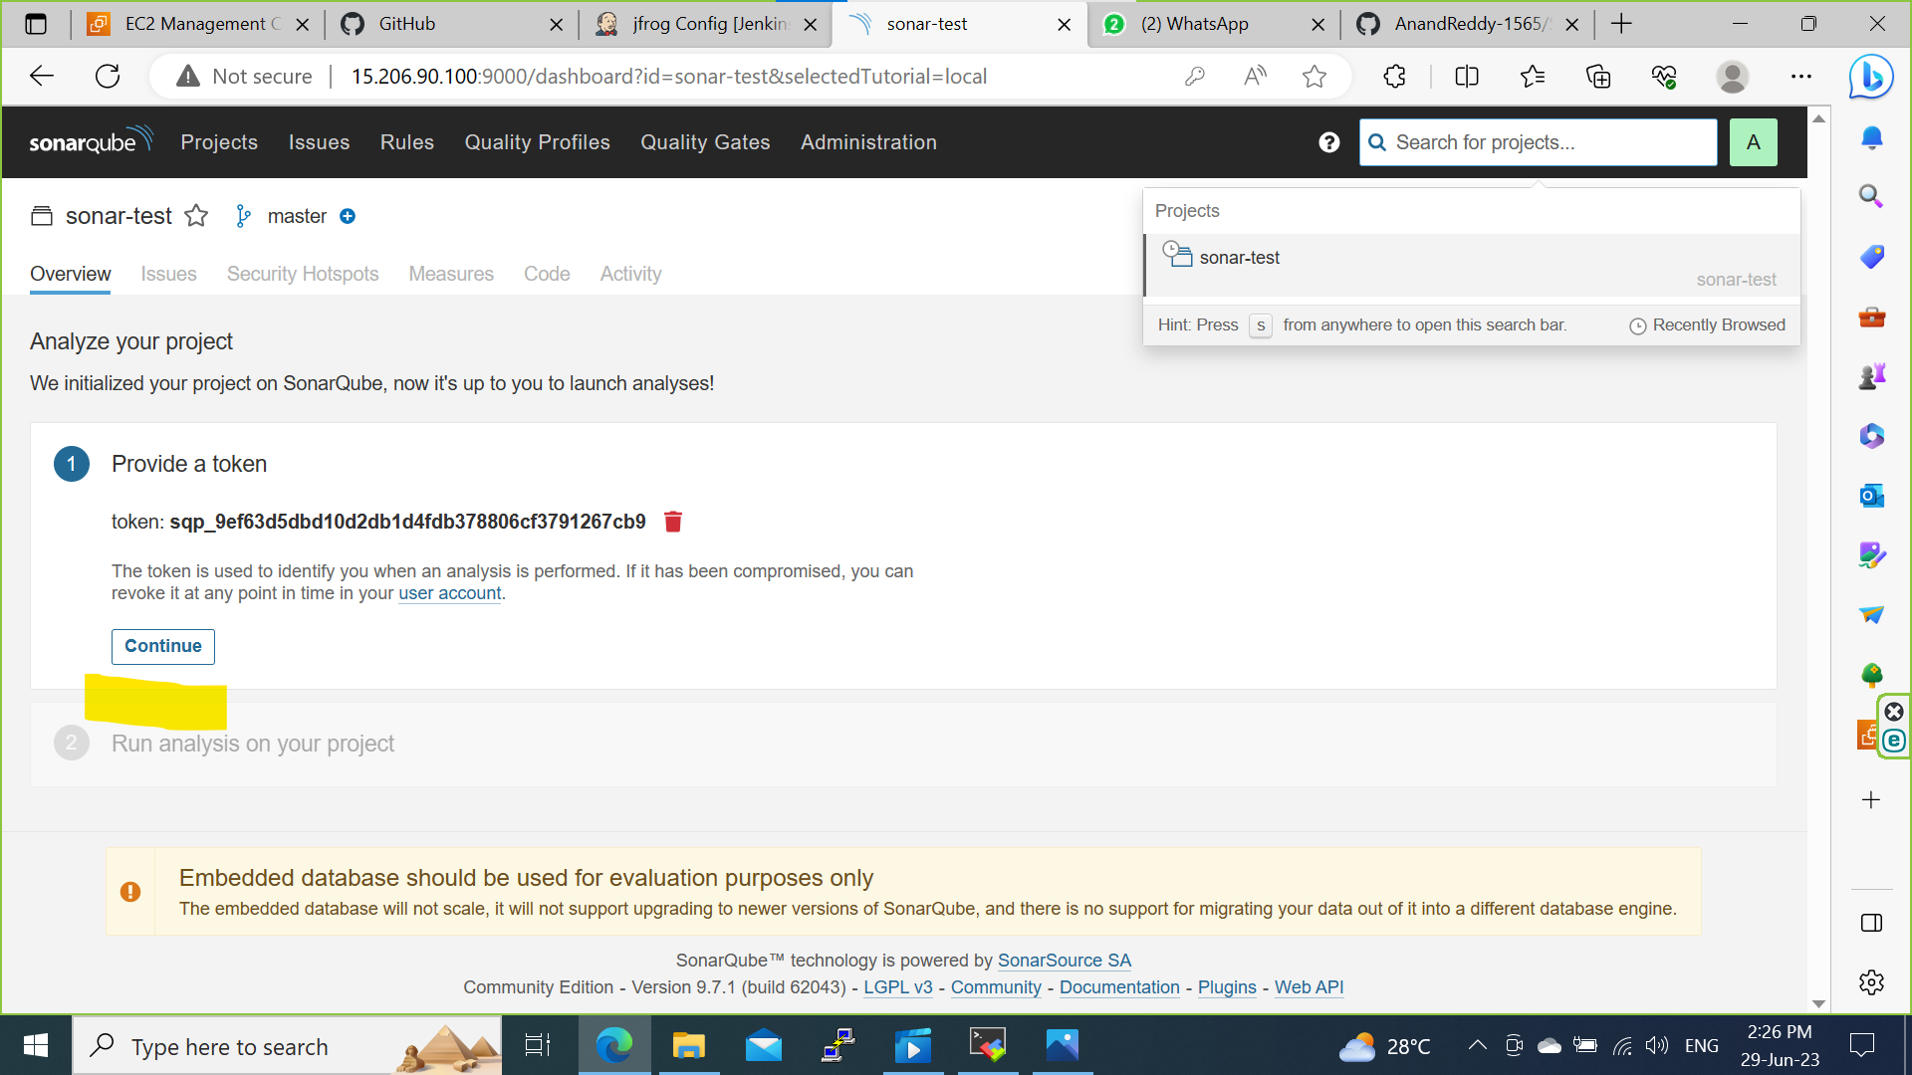

Step 7: Select the Maven and copy the code.

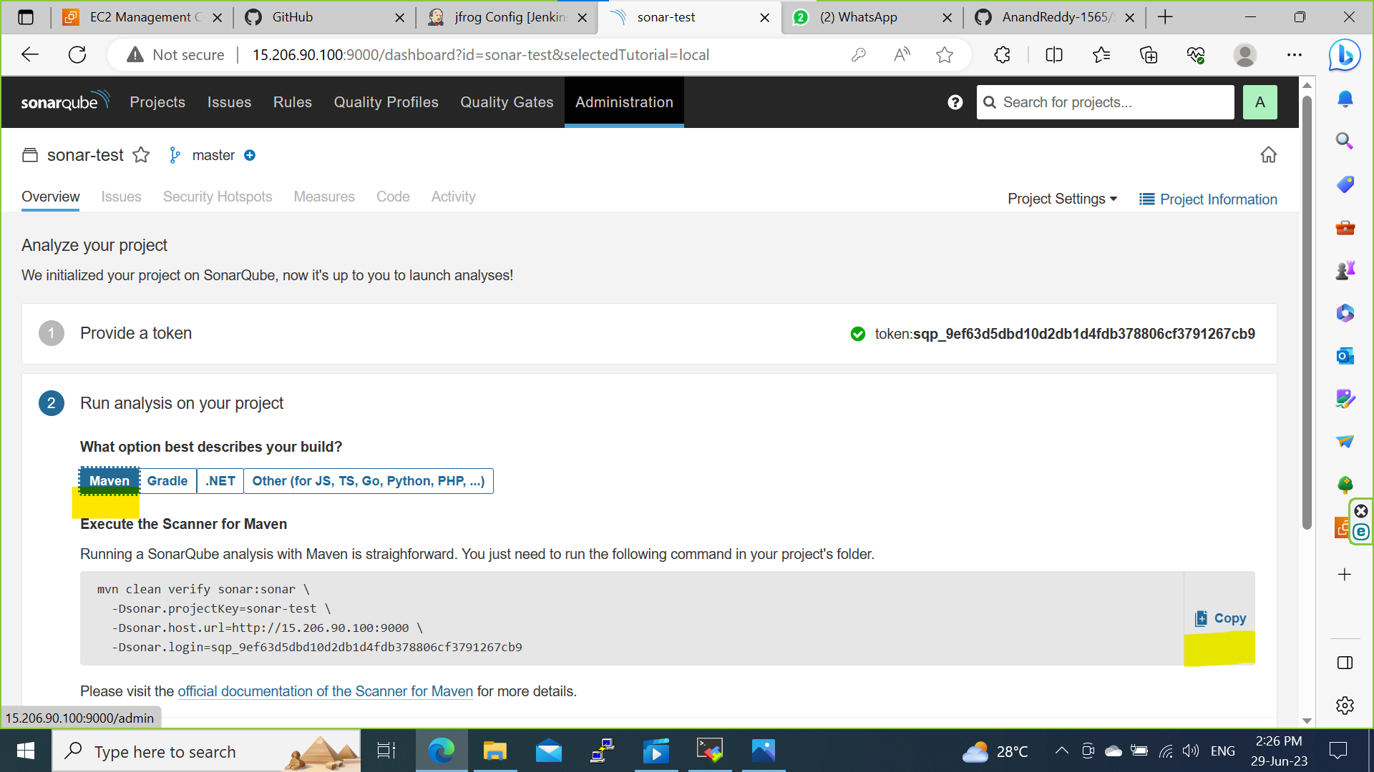

Step 8: Create a POM.xml file and Paste the code in the POM.xml code path.

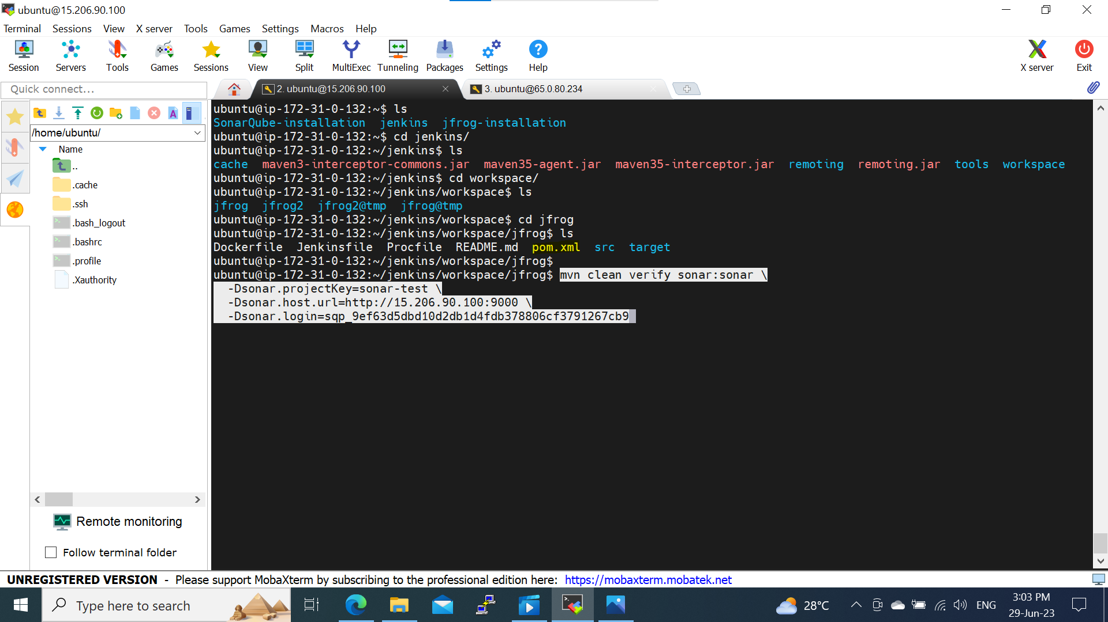

Step 9: Build is success now go to SonarQube webpage and check the Quality of code.

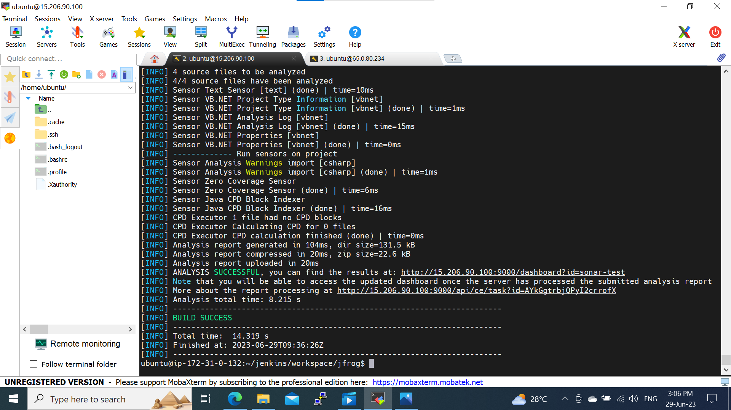

Step 10: Code passed it reached the threshold of 80%.

